Phil Benson
Language Learning Environments
Spatial Perspectives on SLA
MULTILINGUAL MATTERS, Bristol, Blue Ridge Summit, 2021, € 29, 95 (€ 33,37 on Amazon.it)

Luisanna Paggiaro

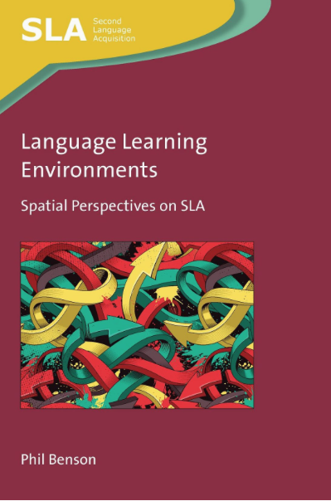 | Ah if one could sail for ever, on a small quiet, lonely ship, from land to land and isle to isle, and saunter through the spaces of this lovely world, always through the spaces of this lovely world. Sweet it would be sometimes to come to the opaque earth, to block oneself against the stiff land, to annul the vibration of one’s flight against the inertia of our terra firma! but life itself would be in the flight, the tremble of space. Ah the trembling of never-ended space, as one moves in flight! Space, and the frail vibration of space, the glad lonely wringing of the heart. Not to be clogged to the land any more.  (D. H. Lawrence, Sea and Sardinia, 1921: 86)  This quotation, chosen by the author (p. 43), as an example of the romanticised view of space - freedom, opposed to the inert solidity of ‘the opaque earth’- wonderfully introduces the complexity of the notion of space.

To introduce this thought-provoking book by Phil Benson, I would like to start from what the author asserts on its final page (Coda), in which he explains the background and the rationale of his research: “begun in 2018, written in Sydney, Australia, during the global pandemic of 2020, when our uses of space have been regulated as never before, by lockdowns, curfews, international border controls and domestic travel bans”, this essay reminds all of us of “how much space matters”. It is just in this “new awakening, awareness and appreciation of local and immediate physical environments (we now know the five kilometre radii around our homes better than ever before)” (p. 260), that the question of space is of paramount importance in our living and mostly in our learning.
In such a framework, exploring the meaning and the function of the space in Second Language Acquisition (SLA) implies considering the process of globalization all over the world with its main aspects of migration, multilingualism, education and tourism, which have led to a growing second language teaching and learning industry in the public and private sectors. “Globally, the where of second language learning is about who gets to learn second languages in various parts of the world, which languages they learn, their learning purposes and the competencies they develop” (p. 17), and this makes the concept of where quite complex and challenging.
Concerning the various terms commonly used to define the where, Benson wishes to specify at the beginning that he prefers to adopt environment and setting to ground context in space, and he defines two perspectives on language learning environments: “an areal perspective in which the environment is viewed as a geographically demarcated area (e.g. a campus, a city or a region) and an individual perspective in which the environment is viewed as a configuration of settings assembled by an individual learner. ” (p. 24). Both perspectives are described in detail in Chapter 5, where the macro and micro systems of language learning intertwine and the role of individual learners in creating or assembling environments from the spatial resources available to them is prominent, thereby opening up new opportunities and challenges for autonomous study.
In Chapter 2, Theories of Space, the author criticizes the largely taken-for-granted view ‘objects-in-space’, i.e. thinking of space as ‘empty’ and of things happening ‘in space’, and supports the critical spatial theory of ‘objects-as-space’, in which space consists of, rather than contains, the objects that comprise it. He also refers to a range of approaches, making a brief historical excursus: from the 1950s to contemporary times, mentioning in particular Cresswell (2015) and Low (2016), who both show a preference for place over space (i.e. the transformation of space into meaningful place through human experience), and take into consideration environmental psychology and geography. Besides, he mentions Foucault’s history of space (1986) with its three epochs: “the medieval space of emplacement; the space of extension ushered in by Galileo, in which space became infinitely open and a thing’s place became a point in its movement; and the contemporary epoch in which extension is replaced by relations among sites defined by proximity, series, trees, grids and sites” (p. 38). In such a way, the debate on what is space continues in the whole chapter and raises some fascinating issues: is space continuous, homogeneous and immobile, geometrical and mathematically measurable? Or is it abstract and insubstantial, absolute, universal and infinite? The European theories of Marxism and Capitalism have influenced space and place through its processes of production and urbanization, and have laid the foundations for a deeper analysis of Linguistics and the Spatiality of Language, as focused on in the following chapter.
In fact, in Chapter 3 great attention is paid to the two schools of linguistics that dominated the latter half of the 20th century: “Chomskyan generativist linguistics and a range of functionalist approaches, among which Halliday’s systemic-functional linguistics (SFL) is probably the best known […]. There is a clear spatial difference between the two: for Chomsky language leans towards mind, whereas in Halliday’s account it leans towards the environment” (p. 105 and p. 108). The consequences of these two approaches still influence our vision of linguistics and of the language as an internally structured space: “a space sui generis that contains and organises a content of its own” (p. 121). In this view, second language learners and teachers, who usually tend to confront languages as self-contained objects in space (standardised and packaged in textbooks, dictionaries and grammars), should become aware of “the sense in which language becomes physical and is set on the move” (p. 122).
Later on in the book, Benson reflects on the two phenomena arising from accelerated global mobility which are currently shaping language learning environments on a global scale: the multilingual city which has emerged as the principal framework for language learning environments on the ground, and online multilingualism. He asserts that the online space is ‘physical’ and recognizes that broadcast and digital information flow more freely and in multiple directions simultaneously because of their ‘weightlessness’, and because of this they may have perceptual effects on our way of living and learning. “The point is not to be finicky about the use of them”, he concludes, “but to maintain an awareness of how spatial circumstances in which learners go online – what devices they use, where they are located and what other human and non-human resources are assembled in the setting - may impact the learning that takes place” (p. 205).
In the last chapter the author discusses, from an autobiographical point of view, a number of studies that have influenced the development of his thinking on language learning environments, and refers to his experiences of teaching English as a second language in Africa, the Middle East and Asia. He describes how in multilingual cities international students learn in educational settings (libraries, extracurricular clubs, open spaces and ‘schoolscapes’), but their learning experiences intersect with experiences of work and pathways to migration. Finally, he reports how language learning research was carried out in schools and universities in terms of custom-designed facilities (self-access centres, computer laboratories and other kinds of learning spaces), and describes the different methods that were used (direct observation, visual and walking methods/interviews) “as a means of capturing how language environments are assembled in both space and time” (p. 259).
A very detailed References and wide Index close the book and provide further study hints for readers wishing to continue on this stimulating journey through the spatial dimensions of language, language learning, linguistics and second language acquisition research.

Contents
Figures
Acknowledgements
- The Where of Second Language Learning
- Theories of Space
- Linguistics and the Spatiality of Language
- Language-Bearing Assemblages
- Language Learning Environments
- Space and SLA Research

References
Index

Author

Phil Benson is Professor of Applied Linguistics and Director of the Multilingualism Research Centre at Macquarie University, Sydney, Australia. He has authored and edited several books spanning his research interests of second language acquisition, autonomy, and language learning beyond the classroom and narrative enquiry.

